CS 255 System Design Document Template

SNHU CS 255
10/12/26
Alec Vokral

UML Diagrams

UML Use Case Diagram

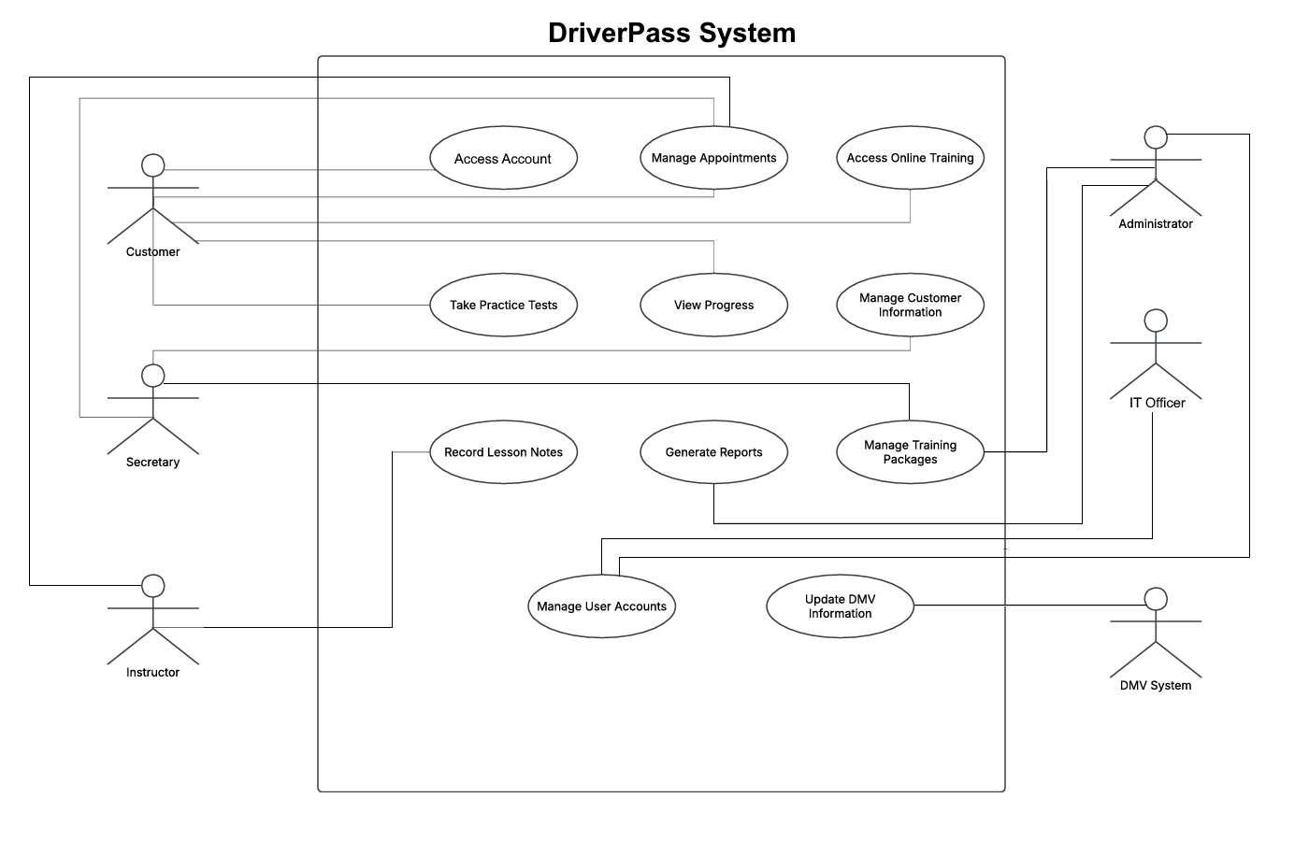

UML Activity Diagrams

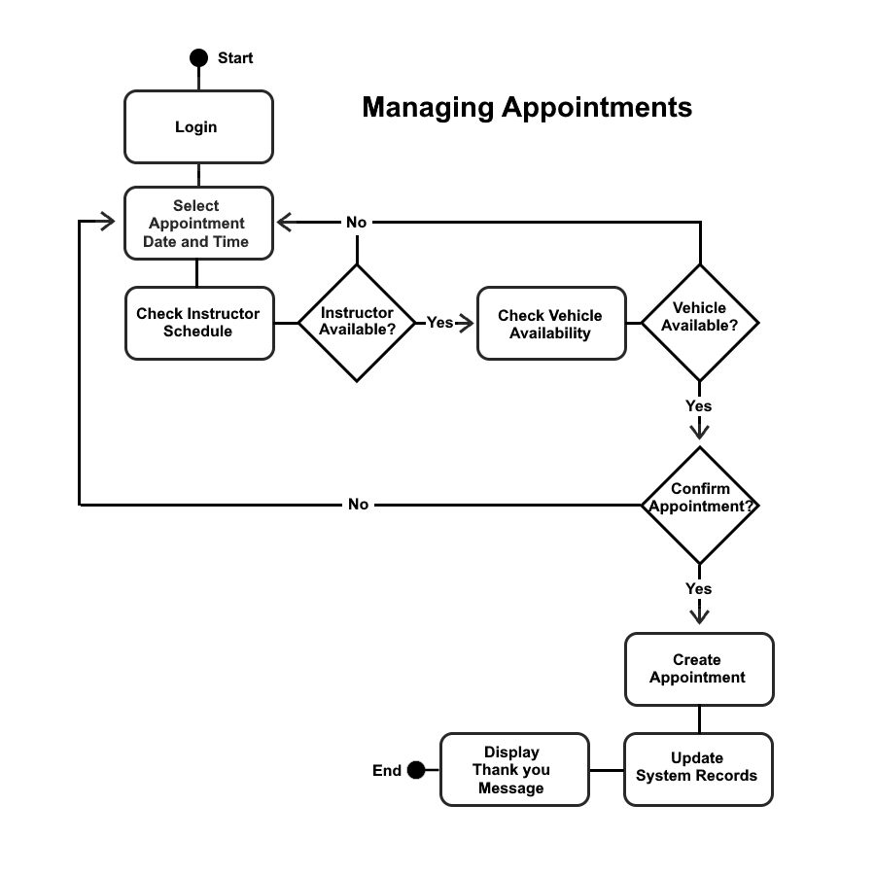

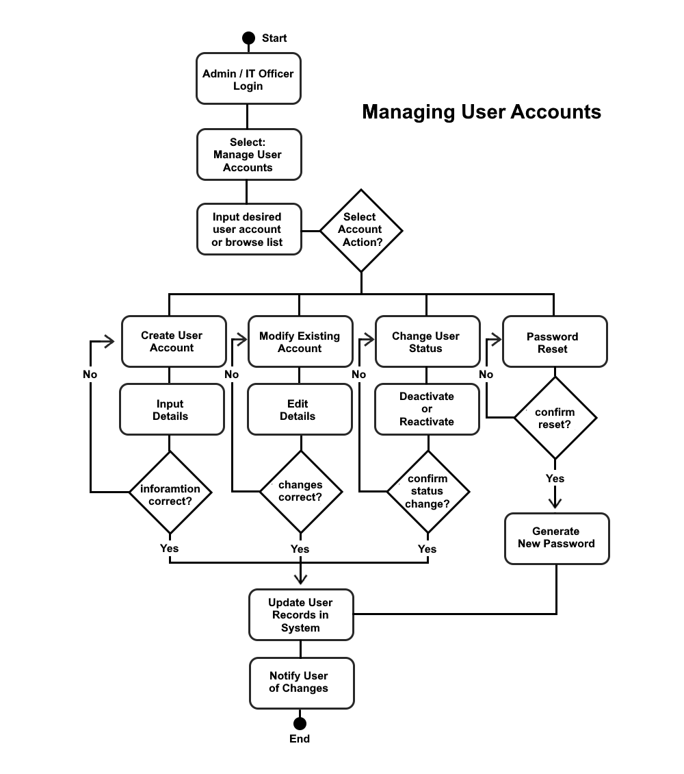

UML Sequence Diagram

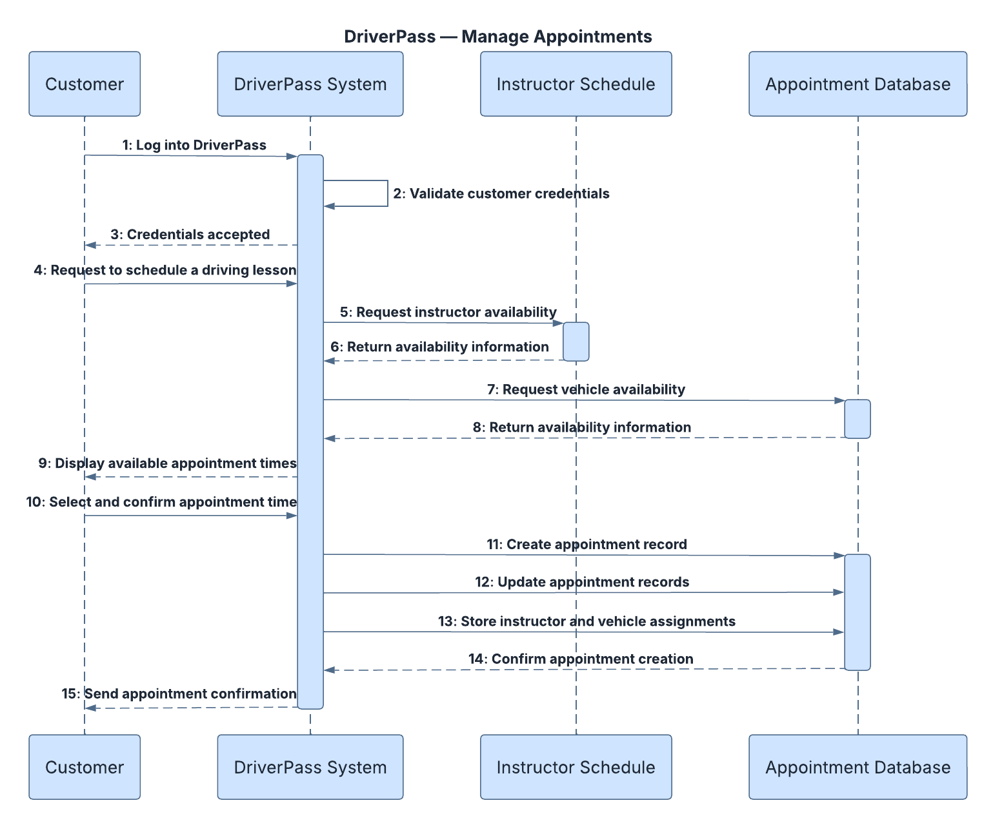

UML Class Diagram

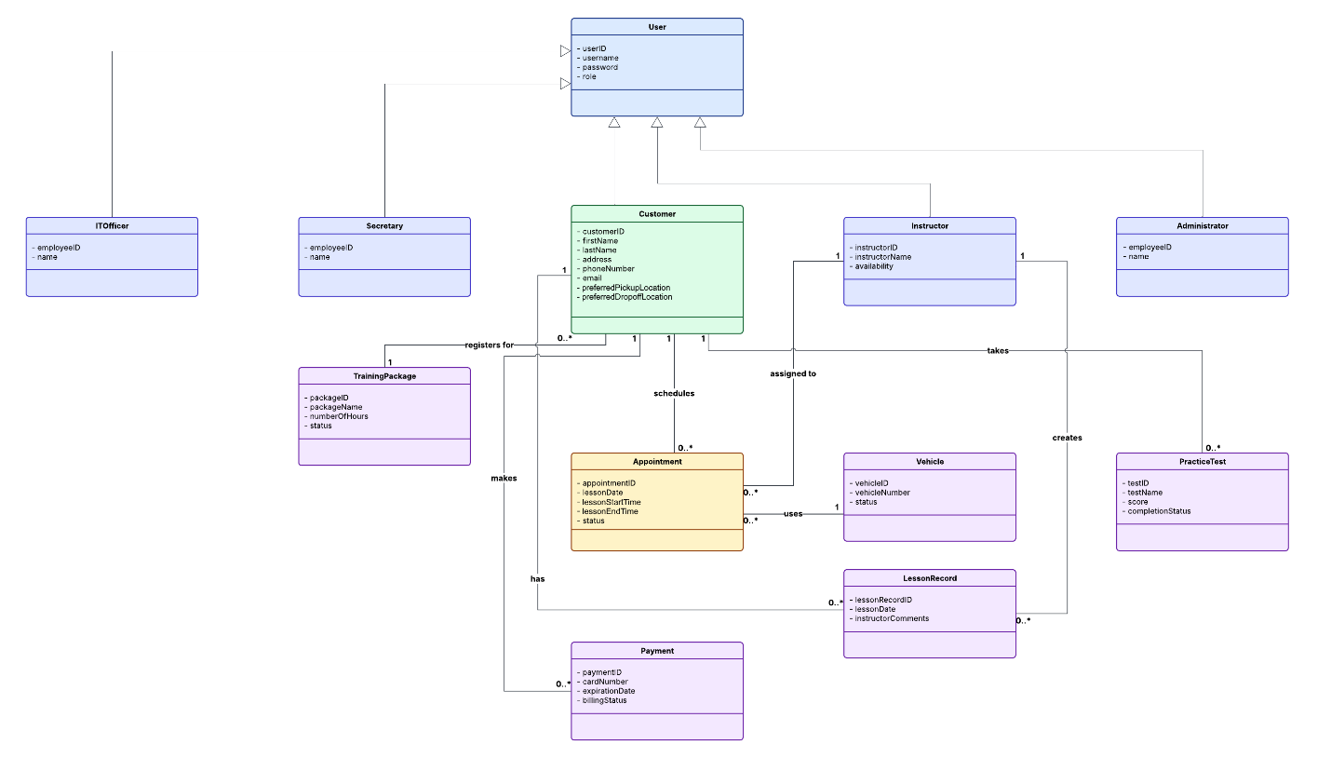

Technical Requirements
The DriverPass system will use a cloud-hosted web application that can be accessed by both customers and employees through an internet connection. Because the system is web-based, users will be able to access training materials, practice tests, lesson schedules, account information, and business reports from a desktop computer, tablet, or mobile device. The system must support appointment scheduling, online training, practice examinations, payment tracking, lesson records, DMV updates, and user account management.

Hardware Requirements
- A cloud-hosted server environment to support the DriverPass web application.
- A database server for storing customer accounts, appointments, training packages, payment information, lesson records, and practice test results.
- Backup storage for data recovery and disaster protection.
- Desktop computers, laptops, tablets, and smartphones capable of accessing the internet.
- Reliable network connectivity for customers and employees using the system.

Software Requirements
- A web-based application that is accessible through modern browsers such as Google Chrome, Microsoft Edge, Mozilla Firefox, and Safari.
- A relational database management system, such as MySQL or Microsoft SQL Server, to store and manage system data.
- Role-based authentication software to control user access based on job responsibilities.
- Software capable of generating reports that can be downloaded and opened in Microsoft Excel.
- Cloud-hosting services that support software updates, backups, and ongoing maintenance.

Infrastructure Requirements
- A cloud-hosted environment that allows DriverPass to focus on business operations rather than maintaining physical servers.
- Secure HTTPS communication between users and the system.
- Internet connectivity to support appointment scheduling, online training, practice testing, and account management.
- Integration with DMV information sources so that DriverPass can receive updates to rules, policies, and testing materials.
- Automated daily backups to protect customer and business information.
- Infrastructure capable of supporting multiple customers and employees working in the system at the same time.

Security Requirements
- The system shall require valid usernames and passwords before granting access to protected features.
- The system shall enforce role-based access controls for customers, secretaries, instructors, administrators, and IT officers.
- Customers shall be able to reset forgotten passwords through a self-service recovery process.
- IT officers shall be able to reset passwords, disable accounts, and manage user access.
- Data transmitted between users and the system shall be protected using TLS encryption.
- Customer personal information, payment information, lesson records, and appointment data shall be protected from unauthorized access.
- The system shall maintain audit logs showing who created, modified, or canceled appointments.
- User accounts shall be temporarily locked after multiple consecutive failed login attempts.

Performance Requirements
- The system shall maintain 99.9% availability, excluding scheduled maintenance periods.
- Appointment information shall be updated within five seconds after an appointment is created, modified, or canceled.
- The system shall support concurrent access by customers, instructors, office staff, administrators, and IT officers without loss of data integrity.
- Online training materials, lesson schedules, and practice tests shall be available whenever users have an internet connection.
- Automated backups shall be performed at least once every 24 hours.

Database Requirements
The database will store and manage the information required to support daily DriverPass operations, including:
- User accounts and role information
- Customer contact information
- Pickup and drop-off locations
- Appointment schedules
- Instructor assignments
- Vehicle assignments
- Training package registrations
- Practice test scores and completion status
- Lesson records and instructor comments
- Payment information and billing status
- DMV updates and notifications
- Audit logs for scheduling and account-management activities

